

**THE UNIVERSITY OF TEXAS AT ARLINGTON, TEXAS  
DEPARTMENT OF ELECTRICAL ENGINEERING**

**EE 5356**

**DIGITAL IMAGE PROCESSING**

**PROJECT # 5**

**by**

**SOUTRIK MAITI**

**1001569883**

**Presented to**

**Dr. K.R.RAO**

**Mar 8, 2019**

**Color Transformation 3b**

*Problem 1 &2 (MATLAB Code):*

clc;

close all;

clear all;

%% Open the RAW image

img_raw = fopen('girl256color.raw','r');

%% Read the RAW image

img_raw = fread(img_raw);

%% Extract the RGB components of the image

R_img_raw = reshape(img_raw(1:3:length(img_raw)),256,256)';

G_img_raw = reshape(img_raw(2:3:length(img_raw)),256,256)';

B_img_raw = reshape(img_raw(3:3:length(img_raw)),256,256)';

%% Make the complete image

I(:,:,1) = R_img_raw;

I(:,:,2) = G_img_raw;

I(:,:,3) = B_img_raw;

%% Display the RAW image

figure

imshow(uint8(I))

title('RAW Image')

saveas(gca,'RAW_image','jpg');

%% For the first problem, we deploy the following algorithm

%% Initialize a matrix of zeros of the same size as that of the image

YIQ_img = uint8(zeros(size(I)));

%% Color space conversions

for i = 1:size(I,1)

for j = 1:size(I,2)

YIQ_img(i,j,1) = 0.299*I(i,j,1)+0.587*I(i,j,2)+0.144*I(i,j,3); % Y component

YIQ_img(i,j,2) = 0.596*I(i,j,1)-0.274*I(i,j,2)-0.322*I(i,j,3); % I component

YIQ_img(i,j,3) = 0.211*I(i,j,1)-0.523*I(i,j,2)+0.312*I(i,j,3); % Q component

end

end

%% Displaying the YIQ color components

figure

subplot(1,3,1)

imshow(YIQ_img(:,:,1))

title('Y Component')

subplot(1,3,2)

imshow(YIQ_img(:,:,2))

title('I Component')

subplot(1,3,3)

imshow(YIQ_img(:,:,3))

title('Q Component')

figure

imshow(YIQ_img)

title('YIQ color space image')

saveas(gca,'YIQ_components','jpg');

%% Reconstructing RGB from the YIQ components

recon_img = uint8(zeros(size(YIQ_img)));

%% Inverse color space conversion

for i = 1:size(YIQ_img,1)

for j = 1:size(YIQ_img,2)

recon_img(i,j,1) = 1.0*YIQ_img(i,j,1)+0.956*YIQ_img(i,j,2)+0.621*YIQ_img(i,j,3); % R Component

recon_img(i,j,2) = 1.0*YIQ_img(i,j,1)-0.272*YIQ_img(i,j,2)-0.647*YIQ_img(i,j,3); % G Component

recon_img(i,j,3) = 1.0*YIQ_img(i,j,1)-1.106*YIQ_img(i,j,2)+1.703*YIQ_img(i,j,3); % B component

end

end

%% Displaying Reconstructed RGB color components

figure

subplot(1,3,1)

imshow(uint8(recon_img(:,:,1)))

title('R Component(Recon)')

subplot(1,3,2)

imshow(uint8(recon_img(:,:,2)))

title('G Component(Recon)')

subplot(1,3,3)

imshow(uint8(recon_img(:,:,3)))

title('B Component(Recon)')

saveas(gca,'Recon_RGB_YIQ','jpg');

%% Displaying Reconstructed Image

figure

imshow(uint8(recon_img))

title('Reconstructed Image')

saveas(gca,'Recon_1','jpg');

**RESULTS:**

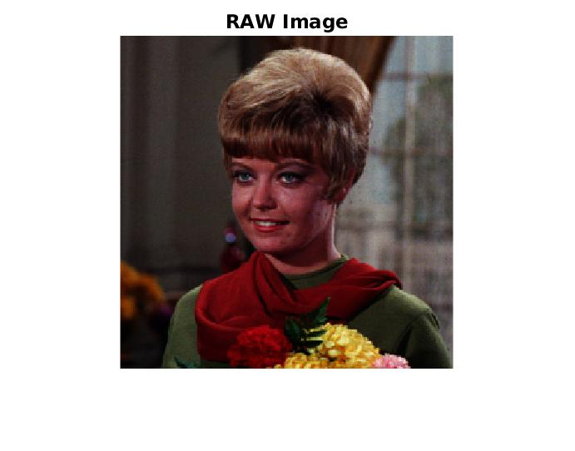

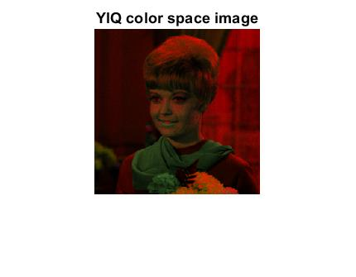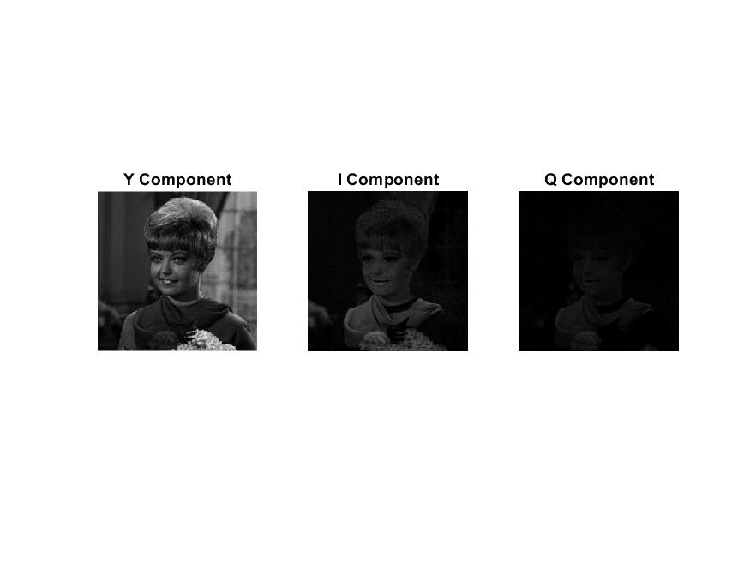

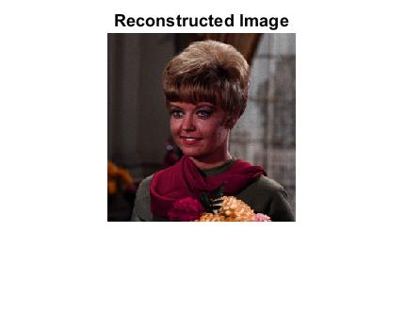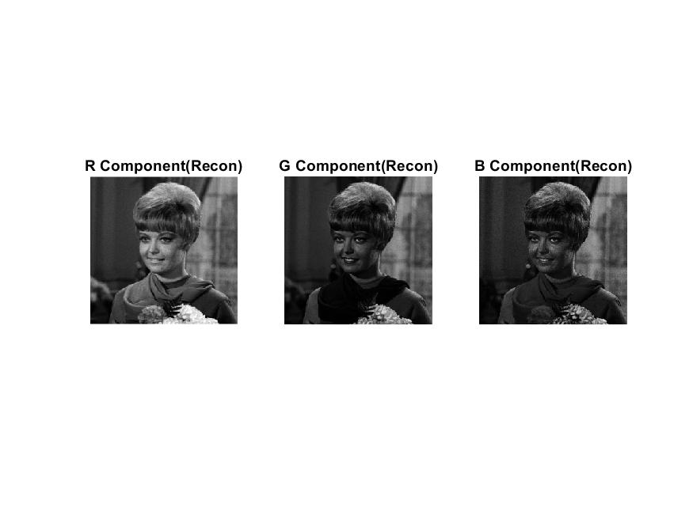

*Problem 3 & 4 (MATLAB Code):*

clear all; clc; close all;

%% For problem 3 we convert RGB to YCgCo

%% Read the image

img = imread('flowers.bmp');

%% Color space conversion algorithm

Y = double(0.25*img(:,:,1)+0.5*img(:,:,2)+0.25*img(:,:,3)); % Y Component

Cg = double(-0.25*img(:,:,1)+0.5*img(:,:,2)-0.25*img(:,:,3)); % Cg component

Co = double(0.5*img(:,:,1)-0.5*img(:,:,3)); % Co component

%% Displaying original image

figure,imshow(img)

title('Orignal Image')

saveas(gca,'original_image','jpg');

%% Displaying the YCgCo components

figure,subplot(1,3,1)

imshow(uint8(Y))

title('Y Component')

subplot(1,3,2)

imshow(uint8(Cg))

title('C_g Component')

subplot(1,3,3)

imshow(uint8(Co))

title('C_o Component')

saveas(gca,'YCgCo components','jpg');

%% For problem 4 we do the inverse conversion from YCgCo to RGB

%% Reconstructing to RGB using the following

R = Y - Cg + Co;

G = Y + Cg;

B = Y - Cg - Co;

%% Display reconstructed RGB components

figure

subplot(1,3,1)

imshow(uint8(R))

title('Recon_R')

subplot(1,3,2)

imshow(uint8(G))

title('Recon_G')

subplot(1,3,3)

imshow(uint8(B))

title('Recon_B')

saveas(gca,'Recon_RGB_YCgCo','jpg');

%% Reconstructing the image

I = zeros(size(img));

I(:,:,1) = R;

I(:,:,2) = G;

I(:,:,3) = B;

%% Displaying reconstrcuted image

figure

imshow(uint8(I))

title('Reconstructed Image')

saveas(gca,'Recon_2','jpg');

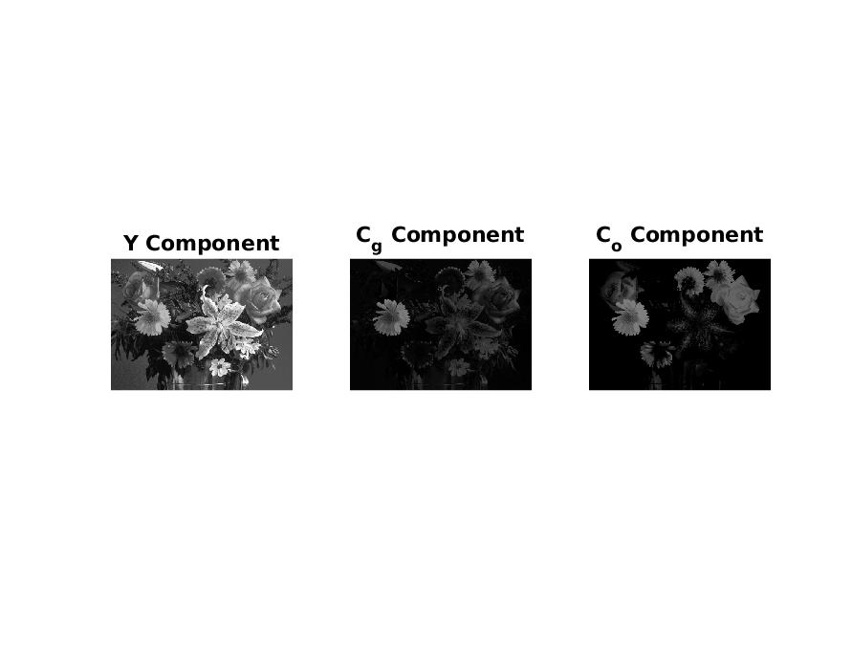**RESULTS:** 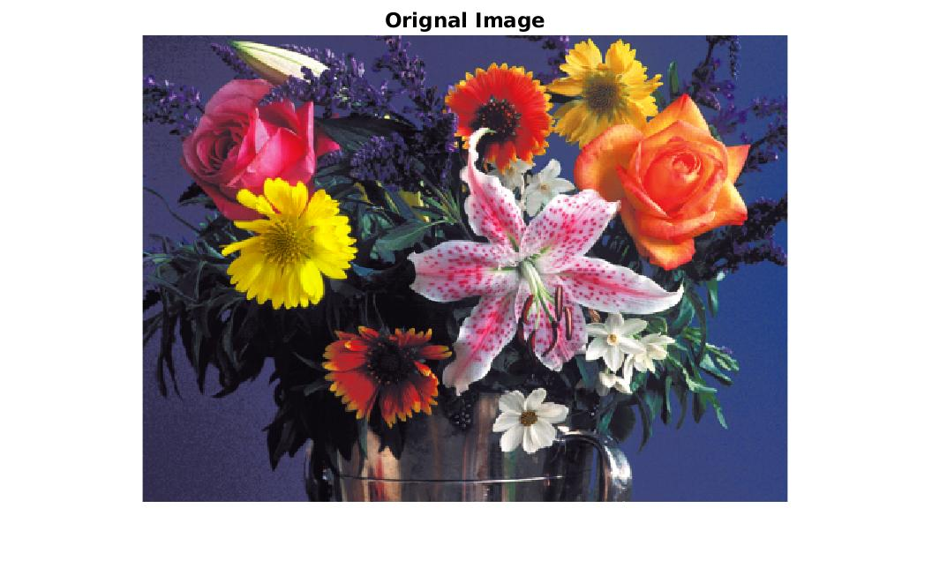

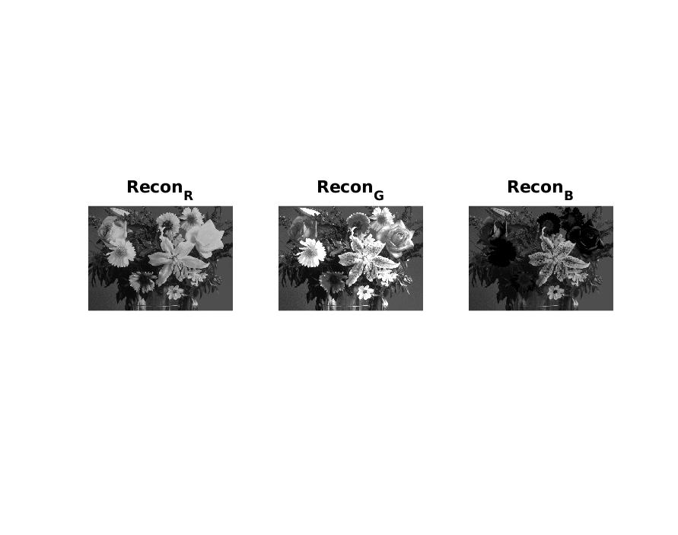

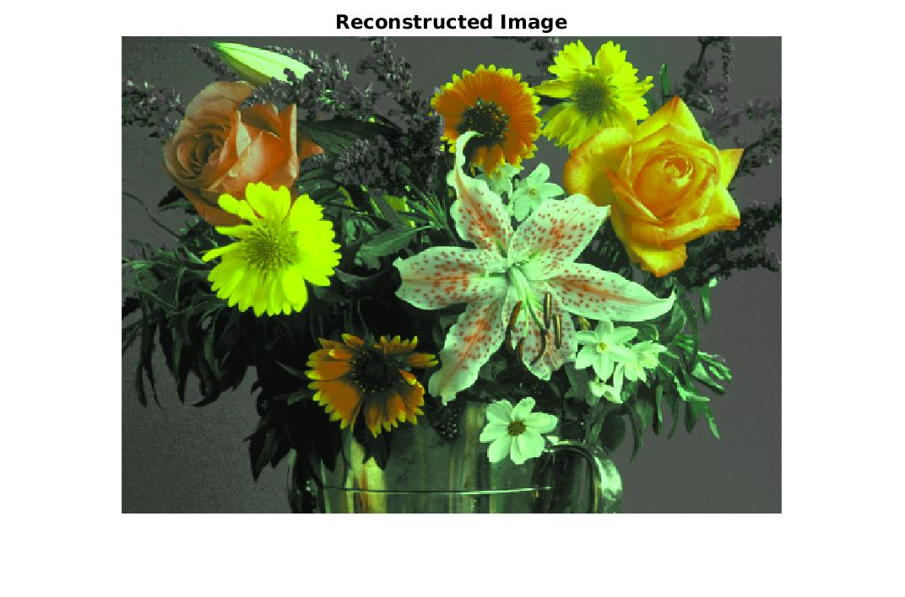

**Conclusion:**

* We first read the RAW image, decompose it into its components – RGB
* We convert the RAW image to the YIQ color space using the matrix given in the problem
* We reconstruct the image from the YIQ color space to the RGB color space using the matrix transform given in the problem.
* For the bmp image, we convert RGB to the YCgCo color space using the matrix given in the problem
* After the YCgCo conversion, we reconstruct the RGB color space Image using the matrix given in the problem
* We reconstruct the image using the inverse color space conversion
* The reconstructed image has a green hue which shows that the reconstruction is not perfect.